1. Set the device to transparent mode in the Bluetooth APP

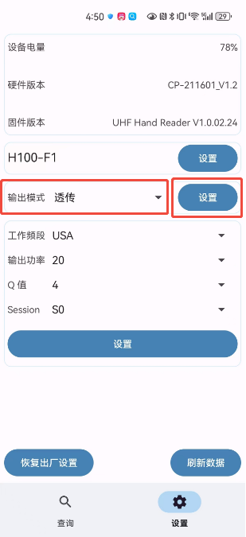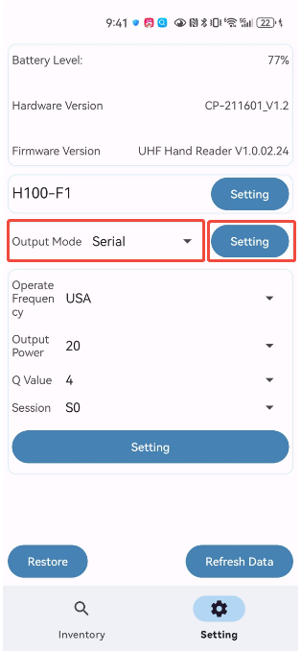

1. Open the Bluetooth software BLEdemo on the computer, search for Bluetooth devices, find the corresponding Bluetooth device, and click OPEN to connect to the Bluetooth device.

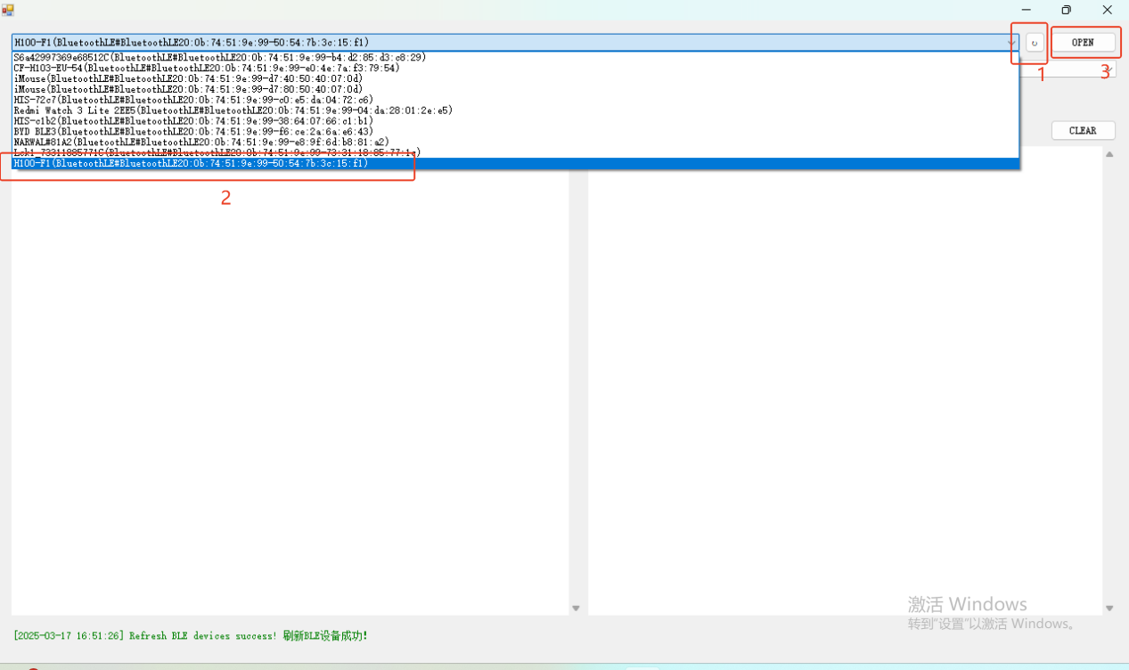

1. Click GET SERVICES to get all Bluetooth services, then find the following service and get the characteristic value of the service

Service: 0000fe0-0000-1000-8000-00805f9b34fb

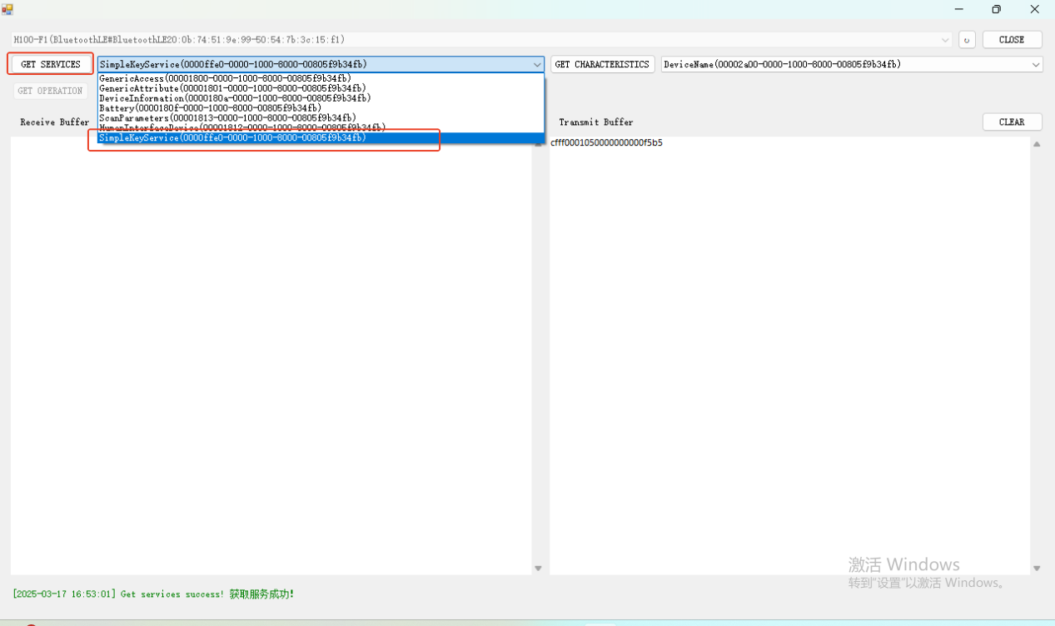

1. Click GET CHARACTERISTICS to get the characteristic value changes, and enable (subscribe) the following characteristic value changes

write: 0000fe3-0000-1000-8000-00805f9b34fb

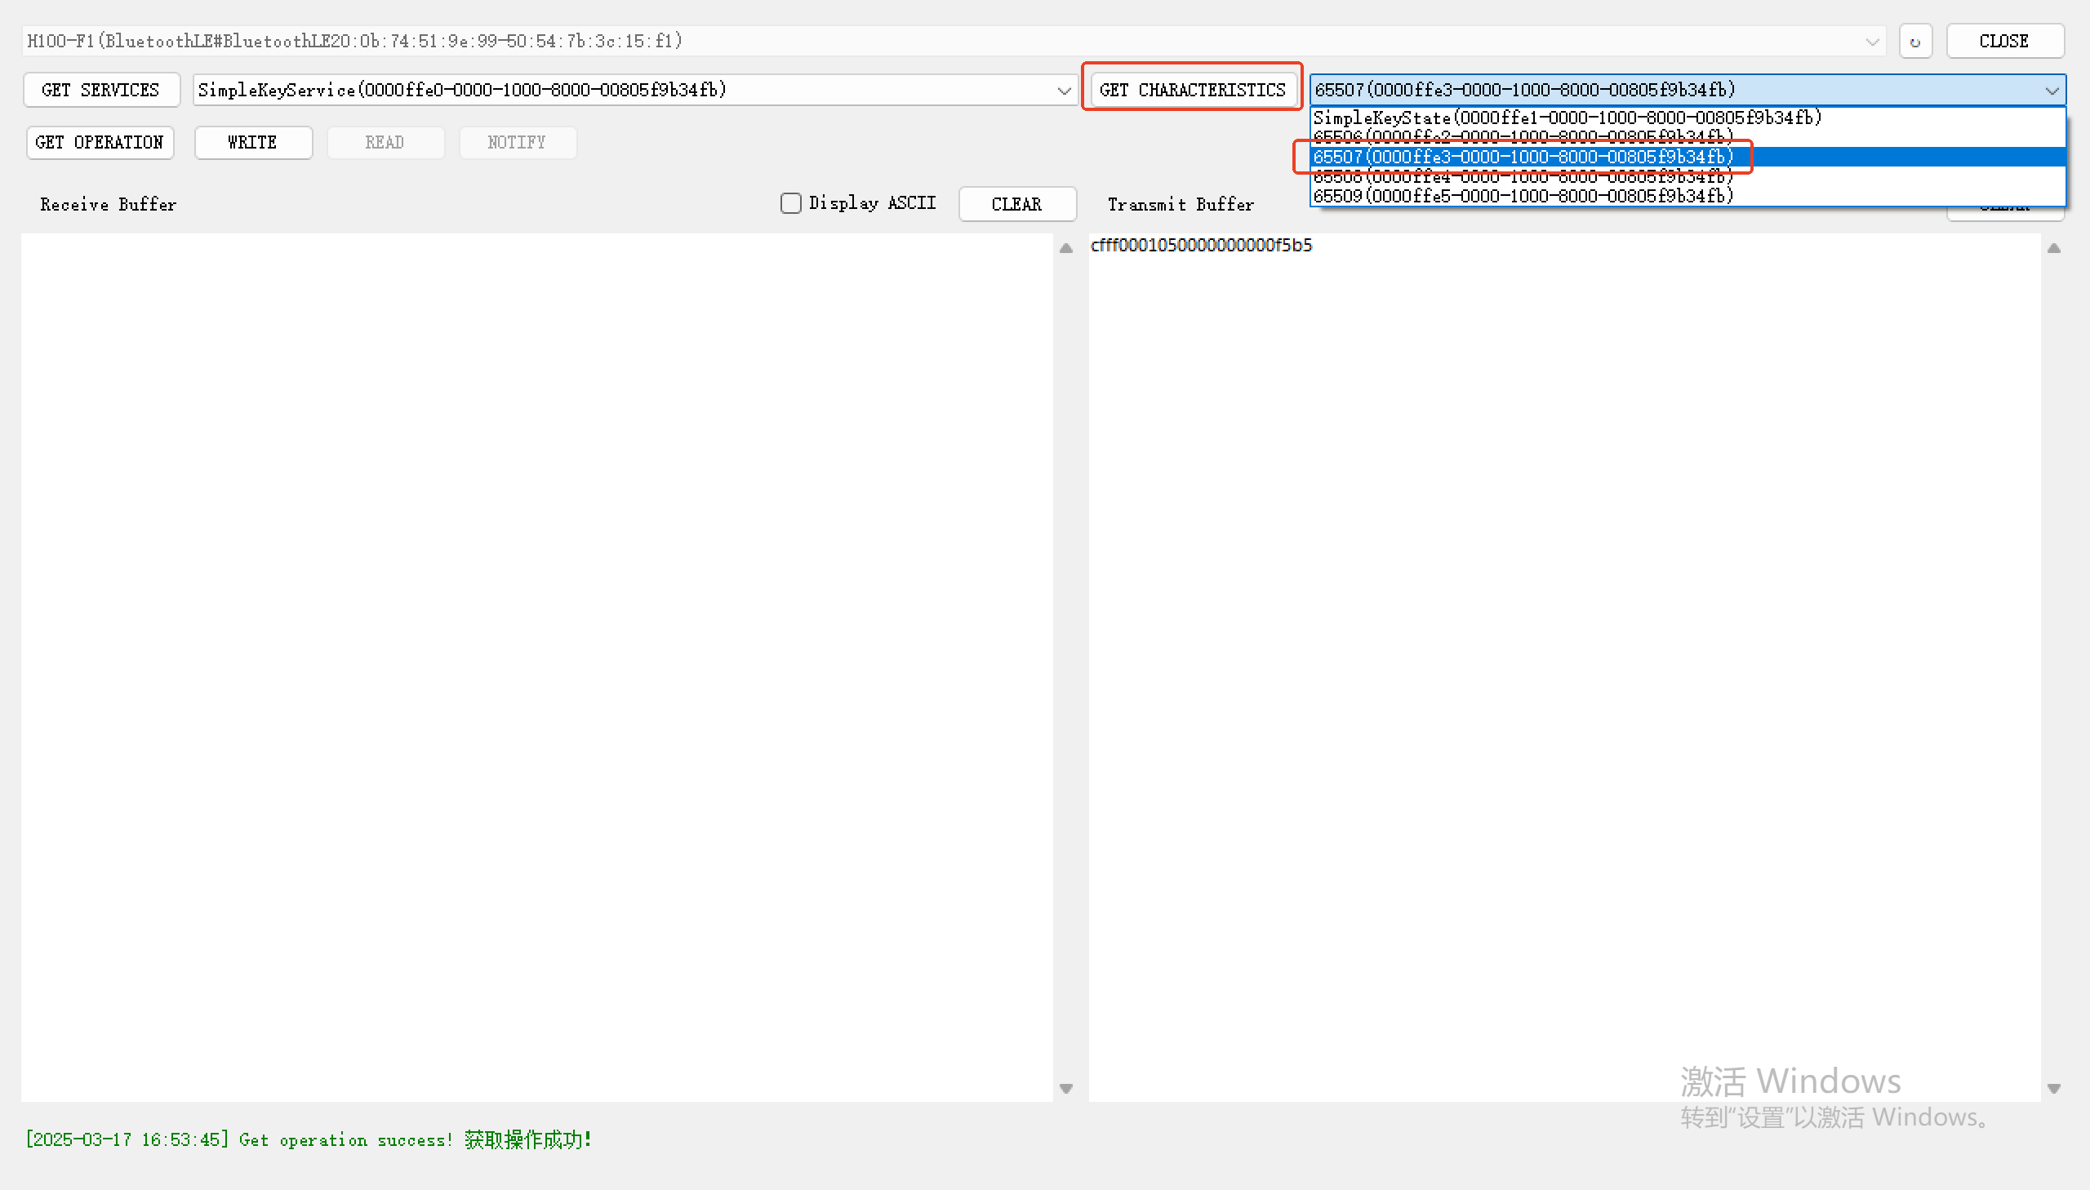

1. Click GET OPERATION, and then in Transmit Buffer, enter cf ff 00 01 05 00 00 00 00 00 f5 b5 (this is the command sent to the device to let the device start reading the card. For specific encoding rules, refer to the UHF Hand Reader Series Reader User Manual V1.2.docx document 2.4.1 RFM_INVENTORYISO_CONTINUE (Tag Inventory)), then click WRITE to issue the command. After issuing the command, put the tag on the device, and you can see that the device is reading the card (the card reader light flashes).

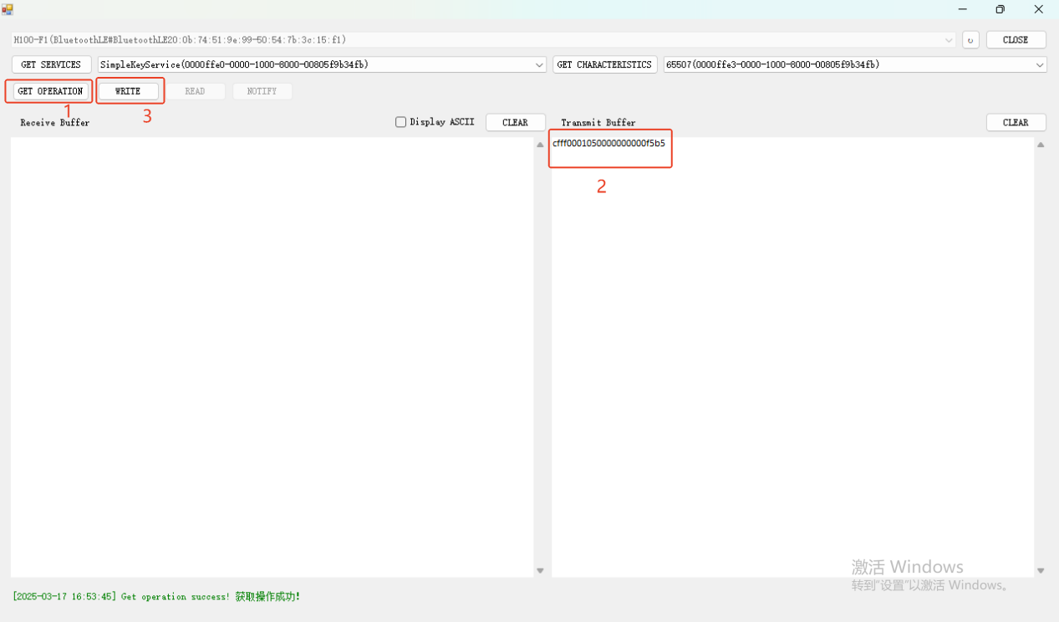

1. Click GET CHARACTERISTICS to get the characteristic value changes, and enable (subscribe) the following characteristic value changes

Notify: 0000fe4-0000-1000-8000-00805f9b34fb

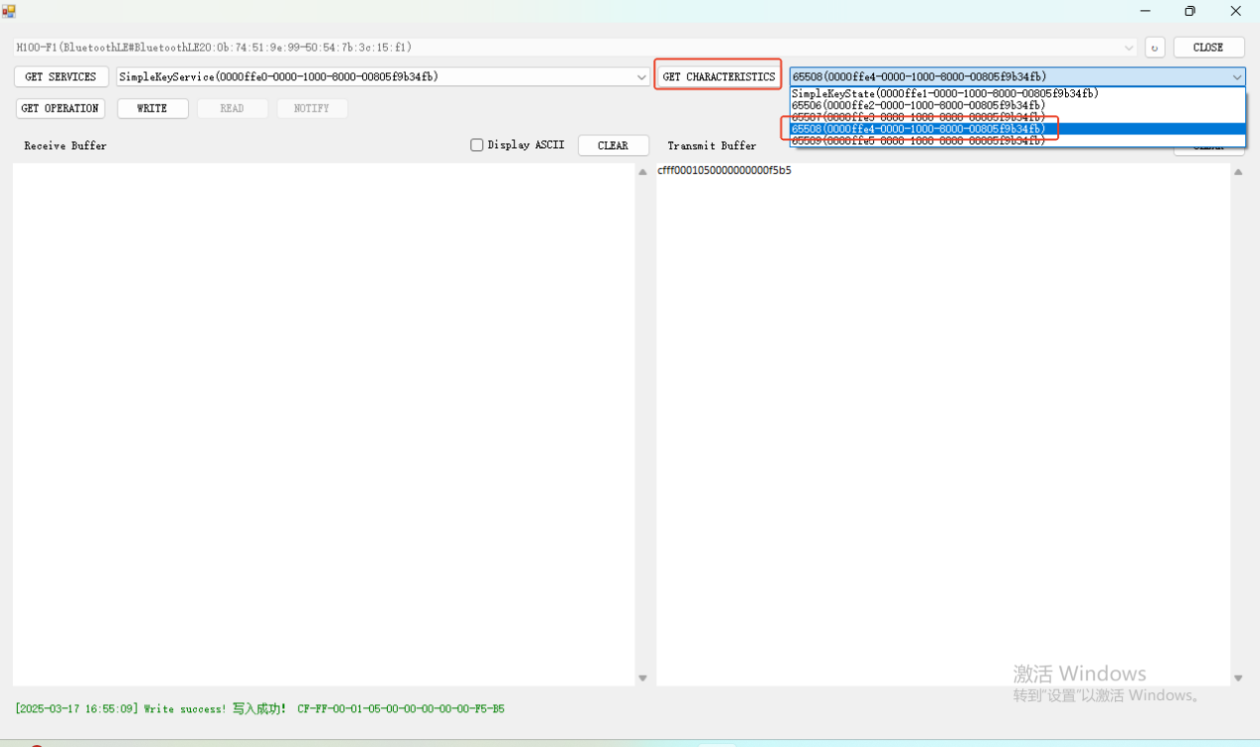

1. Click GET OPERATION, then click NOTIFY to get the data uploaded by the device.

